Seawind 3000, N516SW September 18, 2014
THOMAS A. SACCIO: http://registry.faa.gov/N516SW
NTSB Identification: CEN14LA504
14 CFR Part 91: General Aviation
Accident occurred Thursday, September 18, 2014 in Bloomington, IN
Aircraft: SACCIO THOMAS A SEAWIND 3000, registration: N516SW
Injuries: 2 Fatal.
This is preliminary information, subject to change, and may contain errors. Any errors in this report will be corrected when the final report has been completed. NTSB investigators may not have traveled in support of this investigation and used data provided by various sources to prepare this aircraft accident report.
On September 18, 2014, about 1145 central daylight time, a kit-built Seawind 3000 seaplane, N516SW, impacted terrain near Bloomington, Indiana. The private rated pilot and pilot rated passenger were fatally injured, and the seaplane was destroyed. The seaplane was registered to and operated by a private individual under the provisions of 14 Code of Federal Regulations Part 91 flight. Visual meteorological conditions prevailed and a flight plan was not filed.
Initial reports indicated the pilot contacted the control tower operator at Monroe Country Airport (KBMG), and reported he had a low fuel pressure indicator problem. Several witnesses reported seeing the seaplane, with one witness noting that the seaplane was on fire. The seaplane impacted terrain about 3 miles north of KBMG. A postcrash fire consumed much of the composite seaplane.
The seaplane wreckage was retained for further examination.
Any witnesses should email witness@ntsb.gov, and any friends and family who want to contact investigators about the accident should email assistance@ntsb.gov.

Thomas Anthony "Tom" Saccio
~
Thomas Anthony Saccio: A celebration of his life will be held at 11:00 am, Saturday, October 4, 2014 at the Turnage Theater, 150 W. Main St., Washington, NC officiated by Rev. Peg O. Witt. A catered reception will follow at the Turnage.
A memorial service, A TOAST TO TOMMY, will be in NYC, from 2:00 to 5:00 pm, on Saturday, October 11, 2014 at Grata, 1076 1rst Avenue, NYC 10022 between 58th and 59th streets.
Thomas Anthony Saccio
May 16, 1942 - September 18, 2014
Thomas Anthony "Tom" Saccio, a resident of Blounts Creek, NC, died in a private plane crash on Thursday, September 18, 2014 in Monroe County, Indiana at the age of 72.
The Brooklyn born son of Rose and Joseph Saccio, he is survived by his wife of two years, Stephanie; his three brothers, Joseph, Phillip and Michael; his two sons, Matthew and Michael, Michael's wife Josselyne; his five grandchildren, Thomas, Chelsea, Sophie, Sage and Shane Saccio; his two stepsons, Jason and Chris Lea, Chris's wife Christina and their children, Caitlyn and Cameron Lea.
Thomas's career as a Property Master in Local 52 spanned four decades. He is best known for his work on blockbuster films Raging Bull, Annie Hall, Kramer vs. Kramer, The World According to Garp, Clear and Present Danger, and The Pelican Brief.
In addition to his family and friends, Thomas enhanced the lives of all who knew him, especially the countless young filmmakers to whom he generously lent his expertise, and the thousands of young people with whom he shared his passion for flying. He was the driving force behind Wright Flight - a program that teaches young people how to set and achieve their goals. His commitment, passion, humor, and heart will live on in everyone he touched. His final moments were spent doing what he loved most - flying the plane he built himself.
Thomas will be greatly missed by all those he helped soar to new heights. He is loved. He is appreciated. He is honored.
A celebration of his life will be held at 11:00 am, Saturday, October 4, 2014 at the Turnage Theater, 150 W. Main St., Washington, NC officiated by Rev. Peg O. Witt. A catered reception will follow at the Turnage.
A memorial service, A TOAST TO TOMMY, will be in NYC, from 2:00 to 5:00 pm, on Saturday, October 11, 2014 at Grata, 1076 1rst Avenue, NYC 10022 between 58th and 59th streets.
In lieu of flowers, the family suggests memorials may be made in Tom's memory to Wright Flight of Beaufort, PO Box 369, Washington, NC 27889.
- Source: http://www.hillsidefuneralservice.com
MONROE COUNTY, Ind. (WISH) – The Monroe County Coroner’s Office has identified the two victims who died in a fiery plane crash on Thursday.
Russell Kotlarek, 51, of Saukville, Wisconsin and Thomas Saccio, 72, of Blounts Creek, North Carolina died from trauma as a result of the crash, according to the coroner. However, their final causes of death are still pending.
The identities of the two men were confirmed using dental records.
The plane crash happened just before 1 p.m. Thursday in a wooded area on Oard Road near State Road 48, about a quarter mile north of the Monroe County Airport.
Investigators believe one of the men on the plane reported a mechanical issue, possibly involving fuel-related mechanisms, to the Monroe County Airport tower personnel. The pilot then requested to land at the airport.
However, while the plane was approaching the airport from the north, it lost altitude and crashed into a small shed and wooded area behind a home. The plane was immediately engulfed in flames.
The coroner said both Kotlarek and Saccio are pilots.
- Source: http://wishtv.com

DEDICATED: Tom Saccio, killed in a plane crash Thursday, works on avionics equipment in the hangar at his Maules Point home.
Beaufort County resident Tom Saccio, a key supporter of the Wright Flight program in Beaufort County, was killed Thursday when an airplane crashed near the Monroe County, Ind., airport.
Witnesses said the airplane was losing altitude and on fire just before the crash in a wooded area close to the airport, said Saccio’s wife, Stephanie, on Friday. She was in Delaware at the time of the crash.
A passenger, who had not been identified by Indiana officials as of Friday, aboard the aircraft also died, according to the Monroe County coroner’s office. Saccio’s wife said it was her husband’s Seawind (a plane able to land and take off on water) that crashed. Some published reports say the aircraft that crashed was an experimental ultralight. Attempts to contact the Federal Aviation Administration for information about the crash were not successful Friday.
A memorial service for Saccio, who lived at Maules Point, will be held in Washington, but the date, time and location have not yet been determined, Stephanie Saccio said.
“I decided while he did this little trip I would go to Delaware to see my son and grandkids. … I’m going to try to do it (memorial service) on a weekend because there are people from so far away and I need time to get it together,” she said.
Saccio shared events related to the crash.
“He was flying the Seawind. He had called me about 45 minutes before it crashed. He was in Madison, Ind., on his way to Bloomington … and he said the trip was great and he had been flying for about three and a half hours. He had a friend with him, who sadly also died,” Saccio said. “He said, ‘I’ll call you in an hour and a half. We’re about an hour and a half away from our destination.’… Two hours go by and I haven’t heard from him, so I left him a couple of voice messages, a couple of email, a couple of text messages and didn’t hear, didn’t hear. I get to my son’s house and said, ‘Something’s wrong.’ He said, ‘No, just wait a little bit.’ I just knew something was wrong.”
Saccio called the Indiana State Police, who advised her to call the Indianapolis International Airport, which connected her with the state trooper investigation the crash.
“He asked me where I was and is someone was with my. I said, ‘Yes.” He said they hadn’t fully identified them. I said, ‘It’s his plane. I know it’s his plane.’ People on the ground said they saw the plane losing altitude and that the engine was on fire. They had called in a request to land. They did not call ‘Mayday.’ They called in a request to land and said that there was a fuel-pressure indicator on. They were about 200 yards, as best as I can tell, from the airport landing strip. They went down behind somebody’s home in a grove of trees and in a chicken coop. Fortunately, nobody else was injured,” she said.
“The coroner assured me that they did not suffer — by the time they hit ground, they were dead,” Saccio said.
On Friday, Sgt. Joe Watts, a public-information officer with the Indiana State Police, said ISP troopers were notified of the crash about 12:58 p.m. Thursday.
“The plane was on fire. It took them probably 30 minutes to extinguish the plane and the wooded area there. The plane was broken apart from the impact. We located the two persons on board there at the crash site. Unfortunately, they were burned beyond recognition,” Watts said.
Someone on the airplane requested permission to land at the airport, and that permission was granted, Watt said. After being unable to raise the aircraft by radio when it was about two miles from then airport, personnel in the tower at the airport noticed a plume of smoke near the airport, Watts said. The tower personnel immediately contact a fire department, and a woman who was mowing her yard and either saw or heard the crash called 911 to report it, Watts said.
The Herald Times of Bloomington reports an investigation into the crash may take weeks to complete, according to Steve Burnham, an investigator with the Federal Aviation Administration. The newspaper also reported that officials at a news conference Thursday afternoon could not confirm if the plane was on fire before crashing. The newspaper also reported the pilot reported a “low pressure fuel indicator” but did not declare an emergency.
The Seawind (its engine above and behind the cockpit) has a futuristic look, but it also reminds one of the Consolidated PBY Catalinas of the 1930s and 1940s.
Tom Saccio, who was a property master in the film industry (mostly in New York), became interested in flying early in his life. That interest eventually resulted in him buying a Seawind kit and putting the seaplane together.
Saccio, in an interviews for Washington the Magazine, said that in the early 1990s, his son gave him three flying lessons as a Christmas present.
“I took those three lesson, and I just didn’t stop. I just kept right on going. … Then somewhere along the line I came up with the idea of building an airplane,” Saccio said in the interview. “Right around the time I got the airplane, the kit, I decided after working 40 years in the film industry that I was never going to get this plane built if I kept working. So, I just retired.”
Saccio began building the plane in Connecticut, but lack of space and other limitations there resulted in him moving. At first, Saccio considered buying a house at an airpark, where people live and keep their planes at their homes. Eventually, Saccio located to Maules Point, where his home and the hangar for the Seawind are about 100 yards apart.
The freedom of being able to take off and land from the waters next to his home is greatly satisfying, Saccio said. Before he built his home, he built a hangar for the Seawind.
Saccio was a volunteer pilot with the local Wright Flight program, in which fifth-graders learn the hard work pays off by studying aviation pioneers such as Orville and Wilbur Wright, who set objectives, worked hard to meet those objectives and overcame obstacles to write their names in the history books.
The focus of the Wright Flight program is the contract a student signs. As part of the contract, the student sets a goal and lists what must be done to achieve that goal, which should be challenging. The program’s preferred goal is to raise a grade in school, say from a B to an A in history or a C to a B in mathematics. Parents are encouraged to assist their children in reaching their goals.
Part of the Wright Flight program calls for students to abstain from using tobacco, drugs and alcohol. The program also provides students a second chance if they don’t meet their goals the first time around. That second chance comes during the next grading period.
Numerous Wright Flight participants are minority or disadvantaged children who probably never would have opportunities to fly in an airplane without Wright Flight.
- Source: http://www.thewashingtondailynews.com
A very proud Tom Saccio stands next to his Seawind 3000 as Ed Lynch looks everything over.
http://s1144.photobucket.com
http://www.pendletontimespost.com
http://www.theindychannel.com
https://twitter.com/abbytonsing/media
http://www.thenewsdispatch.com
http://www.wbiw.com
http://www.heraldtimesonline.com
http://www.wcti12.com
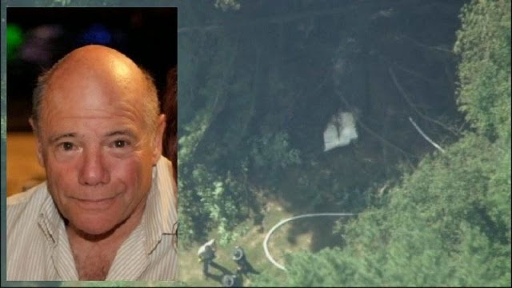Tom Saccio



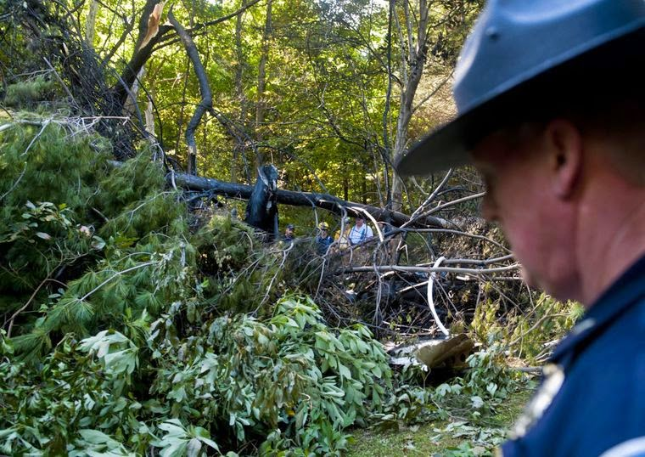

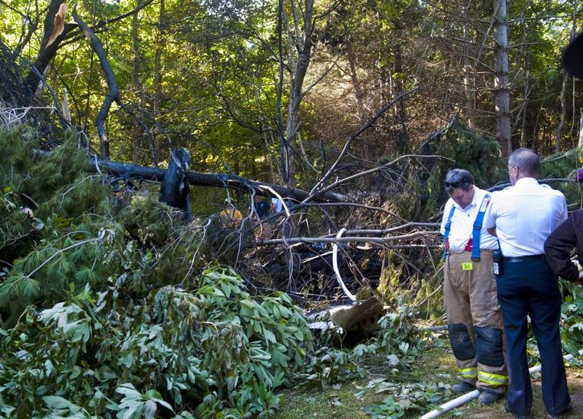

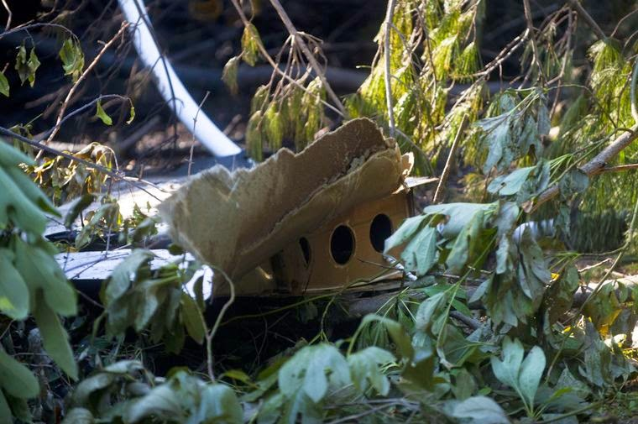

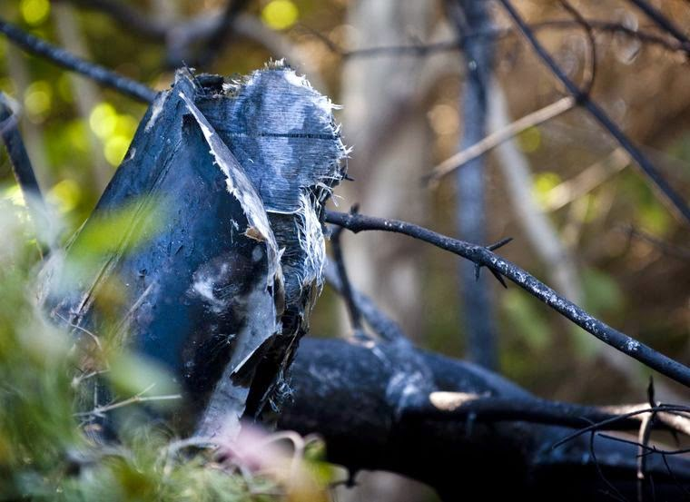

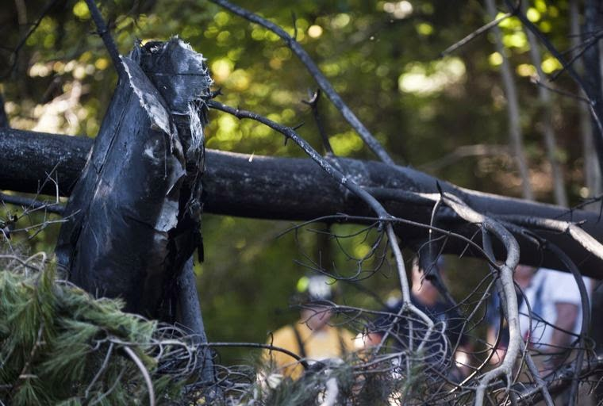
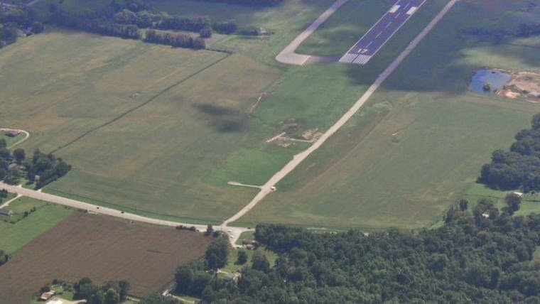

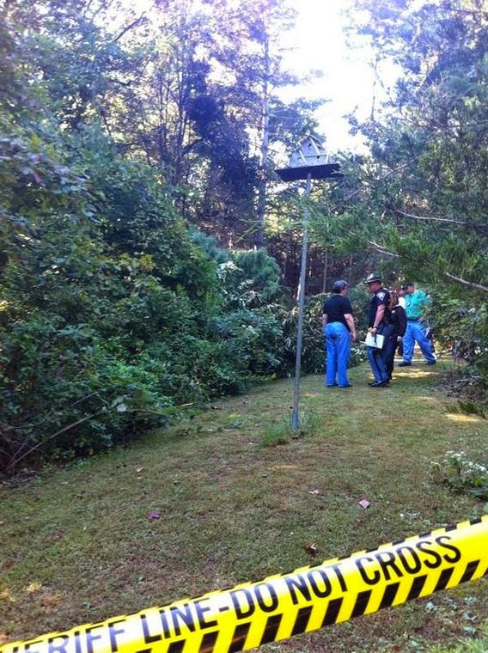

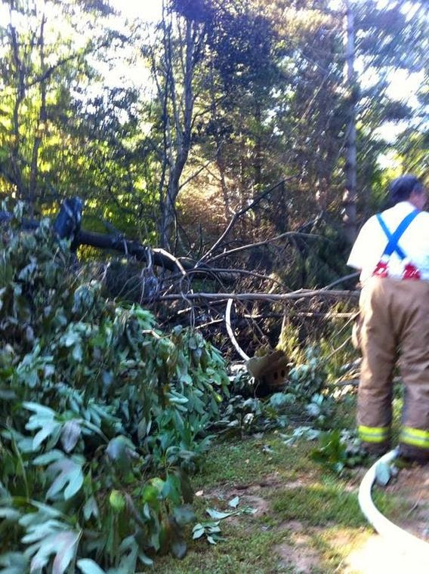

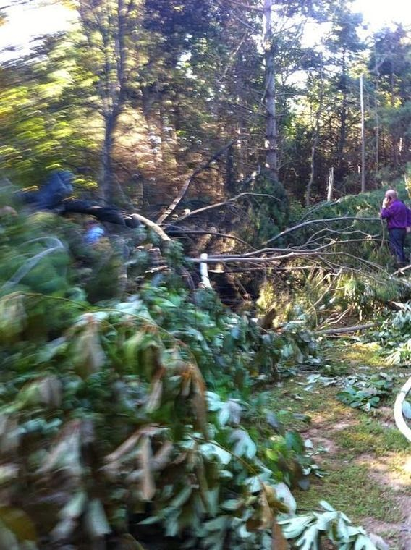

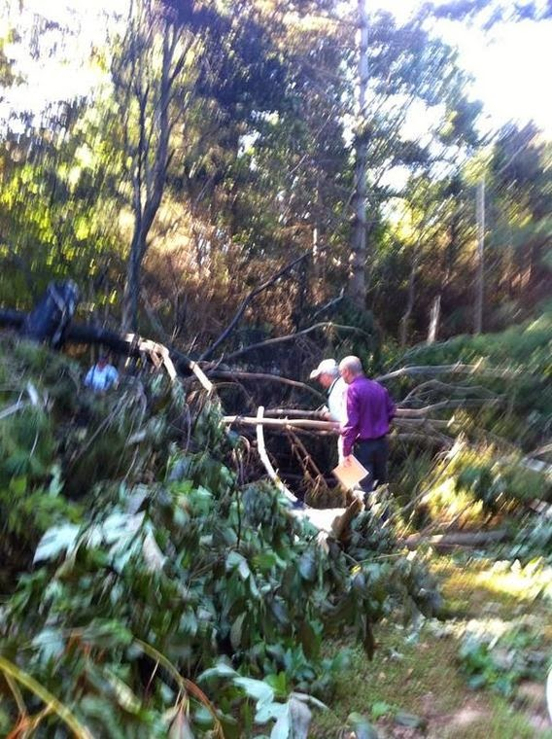

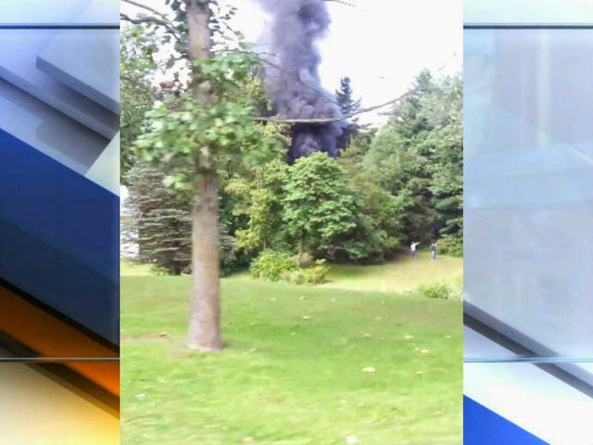

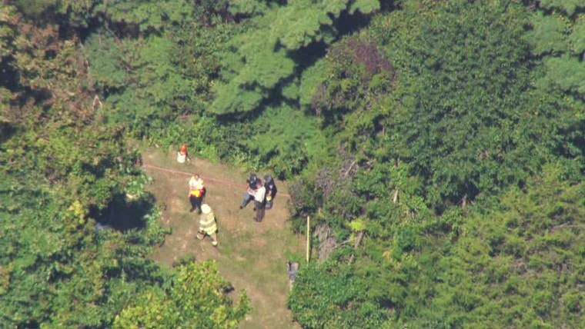
Posted by Kathryn on Thursday, September 18, 2014
NTSB Identification: CEN14LA504
HISTORY OF FLIGHT
On September 18, 2014, about 1145 central daylight time, a kit-built Seawind 3000 seaplane, N516SW, impacted terrain near Bloomington, Indiana. The private rated pilot and pilot rated passenger were fatally injured, and the seaplane was destroyed. The seaplane was registered to and operated by a private individual under the provisions of 14 Code of Federal Regulations Part 91 as a personal flight. Visual meteorological conditions prevailed and a flight plan was not filed.
The pilot contacted the control tower operator at Monroe Country Airport (KBMG) and reported he had a low fuel pressure indicator problem and they planned to fly directly to the airport.
Several witnesses reported seeing the seaplane flying, with one witness noting that the seaplane was on fire prior to the aircraft impacting terrain.
PILOT INFORMATION
The pilot held a private pilot certificate with ratings for airplane single-engine land and sea. He also held instrument-airplane and repairman experimental aircraft builder ratings. The pilot's last class 3 medical exam was conducted on November 21, 2012. At the time of the exam, the pilot reported his flight experience as 765 total flight hours and 20 hours in last six months.
The passenger held a private pilot certificate with ratings for airplane single-engine land and sea. The passenger's last class 3 medical exam was conducted on December 12, 2012. At the time of the exam, the passenger reported his flight experience as 3,400 total flight hours and 50 hours in last six months.
AIRCRAFT INFORMATION
The Seawind is a kit built, composite structure, four seat, amphibian airplane, with a single tail-mounted engine. The airplane was powered by a 300 horsepower (HP) Lycoming IO-540-K1A5 reciprocating engine, which drove a Hartzell, 3 blade, constant speed propeller. A review of Federal Aviation Administration (FAA) records revealed the accident airplane received its special airworthiness certificate in the experimental amateur-built category on September 20, 2007.
METEOROLOGICAL INFORMATION
At 1153, the automated weather observation facility located at KBMG, reported wind from 110 degrees at 4 knots, visibility 10 miles, a clear sky, temperature 68 Fahrenheit (F), dew point 50 F, and a barometric pressure of 30.09 inches of mercury.
WRECKAGE and IMPACT INFORMATION
The seaplane impacted terrain about 3 miles north of KBMG, in a lightly wooded area. A post-crash fire consumed much of the composite structure. Several pieces of composite material were located along the airplane's flight path; the material pieces had evidence of burn areas, consistent with an in-flight fire. After an initial documentation and examination of the wreckage site, the wreckage was removed for examination at a nearby facility.
MEDICAL AND PATHOLOGICAL INFORMATION
The Lawrence County Coroner's Office, Bedford, Indiana, conducted an autopsy on the pilot and pilot rated passenger. The cause of death on both occupants was determined to be injuries sustained in an aircraft crash.
The FAA Bioaeronautical Sciences Research Laboratory, Oklahoma City, Oklahoma, conducted toxicologically testing on the on both occupants. The specimens were negative for tested items.
TEST and RESEARCH
Examination of the airplane was conducted; the fire had destroyed the majority of the airplane. The engine's 3-bladed propeller remained attached to the crankshaft. All three blades exhibited signs of fire/thermal damage, with one blade missing the outboard tip. One blade exhibited slight aft bending, starting about 12 inches from the tip. The engine's fuel servo and fuel pump were destroyed by the fire, and identification part and serial numbers could not be found. The fuel flow divider was dissembled and had suffered thermal damage to the diaphragm. The fuel nozzles and lines to the flow divider were secure. Both magnetos sustained thermal damaged and could not be tested. The sparkplugs were removed and appeared to have normal wear.
On the initial attempt to rotate the engine by manually rotating the propeller, the engine would only turn about 100 degrees before binding. The accessory case was removed and a large amount of melted aluminum was found within the gear train consistent with a melted aluminum case of a magneto. The melted aluminum was removed, and the crankshaft was able to rotate. Thumb compression and valve action was confirmed at each cylinder. The rear accessory gears rotated and mechanical continuity was established throughout the engine drive train. The fire/thermal damage limited a complete examination of the engine; however, based on the limited examination, there was no evidence of pre-impact mechanical malfunctions noted.
During the examination, an electrical wire was found within the wreckage that had signatures consistent with fraying and a piece of metal attached. A fuel line was also found in the same area of the electrical wire that had signatures consistent with thermal damage. Both pieces would have been located in the vicinity of the tail and engine nacelle, a confined area of the tail structure near the engine nacelle.
Sections of both materials were sent to the NTSB Materials Laboratory in Washington DC for further examination. The purpose of examining sections of the fuel line and electrical wire was to identify a potential source of an in-flight fire. The laboratory investigation consequently tried to find evidence of chafing and electrical arcing between the alternator cable and the fuel line. While the laboratory found some evidence of electrical arcing, the tested section was absent evidence of chafing and arcing between the two.
A source of the in-flight fire was not found.

